**Installation Steps of banana pie:**

BPI-M1+ support IR interface on board. you can use it as remote control.

How to use IR interface

test on bananian image:

**1**,install lirc

apt-get install lirc

apt-get install evtest

**2**,edit /etc/lirc/hardware.conf as below:

nano /etc/lirc/hardware.conf

# /etc/lirc/hardware.conf

#

# Arguments which will be used when launching lircd

LIRCD_ARGS="--uinput"

#Don't start lircmd even if there seems to be a good config file

#START_LIRCMD=false

#Don't start irexec, even if a good config file seems to exist.

#START_IREXEC=false

#Try to load appropriate kernel modules

LOAD_MODULES=true

# Run "lircd --driver=help" for a list of supported drivers.

DRIVER="UNCONFIGURED"

# usually /dev/lirc0 is the correct setting for systems using udev

DEVICE="/dev/input/event0"

MODULES="sunxi-ir"

ctrl+O save and ctrl+x exit.

**3**,test lirc

service lirc start

**4** test remote-control unit

evtest

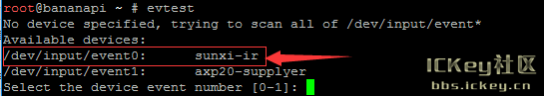

**Fig 3.2.6 Execution 1.**

choose "0" must xunxi-ir

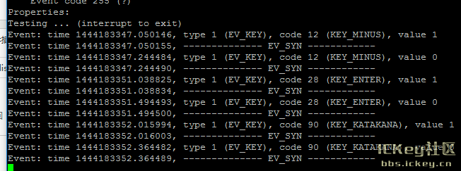

**Fig 3.2.7 Execution 2.**

please note:value 0 value 1

press is:1，unpress is:0